Location-Based Product Search Mobile App

Project Submitted in Partial Fulfilment of the degree of
Master of Computer Applications



Department of Computer Science
University of Delhi
DELHI - 110007

Submitted By:

DEEPAK KUMAR
Examination Roll No: 21234757014
Java Developer Intern
KR Techno Pvt Ltd, Hyderabad

Prof. Mantosh Biswas Mr. Karunakar Reddy
Department Supervisor Company Supervisor

Year 2024

CERTIFICATE

This is to certify that the project work entitled "__________________" has been carried out by Deepak Kumar at KR Techno Private Limited from March 20, 2024 to August 6, 2024 under the supervision of Mr. Karunakar Reddy
and Prof. Mantosh Biswas.

This work has been carried out for the partial fulfilment of the requirements of MCA degree in the Department of Computer Science, University of Delhi.

This project has not been submitted anywhere for the purpose of any other degree or diploma.

Deepak Kumar
Roll No.: 21234757014
MCA Semester 6

Department Supervisor:
Prof. Mantosh Biswas
[Signature] [Date]

Company Supervisor:
Mr. Karunakar Reddy
[Signature] [Date]

Department Head:
Prof. Naveen Kumar
[Signature] [Date]

Acknowledgement

I am profoundly grateful to the Department of Computer Science, University of Delhi, for providing me with the opportunity to pursue an internship at KR Techno Private Limited. This experience has significantly enhanced my technical skills and offered valuable insights into developing a location-based product search mobile application.
I extend my sincere gratitude to Prof. Mantosh Biswas and the esteemed faculty members of the Department of Computer Science for their unwavering support and guidance. Their efforts in facilitating this internship have been crucial in bridging my academic knowledge with practical industry experience.
I would also like to express my heartfelt thanks to my supervisor at KR Techno Private Limited, Mr. Karunakar Reddy. His exceptional guidance, constant support, and constructive feedback have been instrumental in advancing my understanding of mobile application development. His mentorship has been invaluable in helping me navigate the complexities of creating user-centric solutions.
I am thankful for the autonomy and resources provided by KR Techno Private Limited, which enabled me to independently explore and implement new technologies such as Java, Kotlin, Android SDK, Firebase, and Google Maps API. This hands-on learning experience has been essential in equipping me with the skills needed to effectively execute various components of my project.
My appreciation also extends to my colleagues and team members at KR Techno Private Limited. Their collaboration, encouragement, and willingness to share their expertise greatly contributed to a productive and enjoyable internship.
Finally, I am deeply grateful to my family and friends for their unwavering support and encouragement throughout this journey. Their belief in me has been a continuous source of motivation and strength.
Thank you all for making my internship at KR Techno Private Limited a truly memorable and transformative experience.

Sincerely,
Deepak Kumar
TABLE OF CONTENTS

1. Introduction
• 1.1 About KR Techno Private Limited
• 1.2 Project Background
• 1.3 Objectives
• 1.4 Problem Definition

2. Proposed Solution
• 2.1 Technological Integration
• 2.2 Location-Based Services
• 2.3 User Interface Design
• 2.4 Quality Assurance and Testing
• 2.5 Continuous Improvement
• 2.6 Flowchart / Workflow
• 2.7 Explanation of Flowchart Steps

3. Implementation Approach
• 3.1 Languages Used
• 3.2 Database Integration
• 3.3 Tools Used
• 3.4 Deployment

4. Implementation Plan in Detail
• 4.1 Java Language
• 4.2 Android Studio
• 4.3 UI/UX Design Principles
• 4.4 Core Features Implementation
• 4.5 Testing and Quality Assurance
• 4.6 Deployment and Maintenance
• 4.7 Scope and Limitations

5. Simulation of Mobile App
• 5.1 Splash Screen
• 5.2 Create Account
• 5.3 User Login
• 5.4 Location Detection
• 5.5 Home Screen
• 5.6 Fetch Data from Firebase Realtime Database
• 5.7 Display Product Information

6. Discussion
• 6.1 Learning Process and Growth
• 6.2 Technical Skill Development
• 6.3 Problem-Solving and Debugging
• 6.4 Collaboration and Communication
• 6.5 Personal Growth

7. Testing and Debugging
• 7.1 Introduction
• 7.2 Testing Strategy
• 7.3 Debugging Process
• 7.4 Testing and Debugging Outcomes

8. Conclusion
- 8.1 Summary of Experience
- 8.2 Contributions
- 8.3 Future Aspects

9. References
- 1.Android Developer Documentation
- 2.Online Tutorials and Courses
- 3.Articles and Blogs
- 4.Version Control and Collaboration
- 5.User Experience and Design

Chapter 1| Introduction

1.1 About KR Techno Private Limited
KR Techno Private Limited is a dynamic organisation involved in the full life cycle of software products, including development, production, sales, and ongoing maintenance. The company specialises not only in software products but also excels in Android applications, website development, domotics, and IT consulting services, showcasing a diverse and extensive portfolio. Within the technology sector, KR Techno Private Limited plays a pivotal role in pioneering innovative applications, robust systems, and cutting-edge tools tailored for various platforms and devices. The organisation's commitment to technological advancement is evident through its comprehensive approach, meeting client needs and contributing significantly to the evolving landscape of the tech industry.

1.2 Project Background

KR Techno Private Limited is embarking on the development of an advanced location-based product search mobile application, reflecting our commitment to harnessing cutting-edge technology to enhance user experiences and meet contemporary market demands.

1.2.1 Technological Focus: At the core of this initiative lies the integration of leading-edge technologies such as Java, Android SDK, Firebase, and Google Maps API. These technologies will enable the creation of a robust and intuitive mobile application, allowing users to efficiently search for products based on their geographical location.
1.2.2 Strategic Vision: The project's objective is to deliver a seamless and feature-rich application that exceeds user expectations. By blending innovative design with efficient functionality, our aim is to establish new benchmarks in location-based product search technology, delivering substantial value to our users.
1.2.3 Impact and Innovation: Through this initiative, KR Techno Private Limited seeks to make a significant impact in the tech industry by showcasing our expertise in software development and pushing technological boundaries. Embracing innovation and leveraging our technical capabilities, we strive to elevate user experiences and drive business growth for our clients.

1.3 Objectives

1.3.1 Enhance User Convenience: Develop a user-friendly mobile app that allows users to search for products based on their current geographical location, thereby enhancing convenience and efficiency in shopping experiences.
1.3.2 Real-Time Product Availability: Implement real-time integration with product databases and location-based services to provide users with up-to-date information on product availability in their vicinity.
1.3.3 Intuitive User Interface: Design an intuitive and visually appealing user interface (UI) that facilitates seamless navigation and enhances user engagement with the application.
1.3.4 Personalised Recommendations: Utilise data analytics and user behaviour insights to offer personalised product recommendations tailored to individual preferences and location.
1.3.5 Scalability and Reliability: Ensure the application's scalability across different mobile platforms (Android) and robustness in performance to handle varying user loads and maintain high reliability.

1.4 Problem Definition

In the landscape of mobile commerce, there exists a notable challenge in efficiently integrating location-based services into product search applications. Current solutions often lack the seamless integration necessary for users to locate products based on real-time geographical data effectively. This limitation hinders user convenience and diminishes the potential for enhancing retail experiences through mobile platforms.
KR Techno Private Limited recognizes the opportunity to address this challenge by developing a sophisticated location-based product search mobile application. The primary objective is to create a robust solution that leverages advanced technologies—such as Java, Android SDK, Firebase, and Google Maps API—to deliver accurate and real-time product availability based on user location.
Key technical challenges include ensuring data accuracy, implementing reliable real-time updates, and designing an intuitive user interface that enhances usability and accessibility. Scalability across diverse mobile platforms is critical to meeting industry standards and accommodating varying user preferences.
By focusing on these challenges, KR Techno Private Limited aims to redefine the mobile shopping experience by offering a solution that not only meets but exceeds user expectations. The application's success will be measured by its ability to seamlessly integrate location-based services, provide personalised product recommendations, and enhance overall user satisfaction.

Chapter 2 | Proposed Solution

To address the identified challenges and achieve the project objectives, the proposed solution includes the following components:
2.1 Technological Integration: Utilise Java programming languages alongside Android SDK for native app development. Integrate Firebase for backend services, incorporating real-time database capabilities for dynamic product updates and user authentication.
2.2 Location-Based Services: Implement Google Maps API to enable accurate geolocation functionalities and seamless integration with the application's product search feature.
2.3 User Interface Design: Employ modern UI/UX design principles to create an intuitive and visually appealing interface. Focus on simplicity and clarity to ensure ease of use for users of varying technical proficiency.
2.4 Quality Assurance and Testing: Conduct rigorous testing phases, including unit testing, integration testing, and user acceptance testing (UAT), to ensure high standards of performance, reliability, and usability.
2.5 Continuous Improvement: Implement a feedback mechanism to gather user insights and iteratively improve the application based on feedback and market trends. This approach aims to maintain competitiveness and meet evolving user expectations.

2.6 Flowchart / Workflow

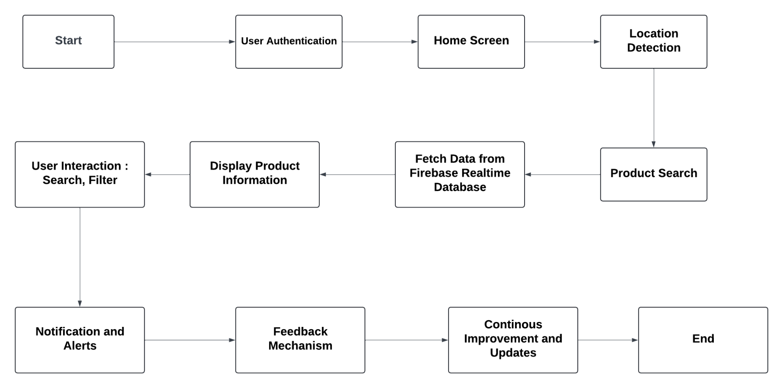

2.7 Explanation of Flowchart Steps:

2.7.1 User Authentication: Users authenticate securely using Firebase Authentication to access the application's features.
2.7.2 Home Screen: Upon successful login, users are directed to the home screen where they can initiate product searches.
2.7.3 Location Detection: The application uses Google Maps API to detect the user's current location or allows manual input for location-based searches.
2.7.4 Product Search: Users enter search queries based on location, product categories, or keywords.
2.7.5 Fetch Data from Firebase Realtime Database: The application fetches real-time product data and availability from Firebase.
2.7.6 Display Product Information: Product details are displayed on the UI, including images, descriptions, prices, and ratings.
2.7.7 User Interaction: Users can interact with displayed products, apply filters, and view additional details.
2.7.8 Personalization and Recommendations: Algorithms analyse user behaviour and preferences to suggest relevant products.
2.7.9 Notifications and Alerts: Push notifications alert users about nearby deals, new products, or personalised offers based on location and preferences.
2.7.10 Feedback Mechanism: Users provide feedback through the app, influencing future updates and improvements.
2.7.11 Continuous Improvement and Updates: The development team iterates based on feedback, analytics, and market trends to enhance functionality and user experience.

Chapter 3 | Implementation Approach

3.1 Languages Used
Java is used for the implementation of various functionalities. Java's robustness, ease of use, and extensive libraries make it an ideal choice for building scalable and efficient applications.

3.2 Database Integration
For database integration, NoSQL databases are employed. Specifically, Firebase Realtime Database and Firestore are used. These databases provide real-time data synchronisation, offline capabilities, and are highly scalable, making them suitable for dynamic applications.

3.3 Tools Used

3.3.1 UI/UX Design
- Figma: Figma is utilised for designing user interfaces and user experiences. It offers a collaborative environment for designing prototypes and wireframes, ensuring that the design process is efficient and visually appealing.

3.3.2 Frontend Development
- IDE (Android Studio): Android Studio is the integrated development environment used for frontend development. It provides powerful coding and debugging tools, an easy-to-use interface, and is specifically designed for Android application development.

3.3.3 Database Integration
- Firebase Console: The Firebase Console is employed for managing the NoSQL databases. It offers tools for real-time data monitoring, database management, and security rule configuration, facilitating efficient database integration.

3.3.4 Testing
- JUnit: JUnit is a unit testing tool used to test the application. It helps ensure that individual units of source code work as intended, providing a framework for writing and running repeatable tests.

3.4 Deployment
3.4.1 Google Play Console: The Google Play Console is used for deploying the application. It allows for app distribution, performance monitoring, and user feedback management, ensuring a smooth and controlled deployment process.

Chapter 4 | Implementation Plan in Detail

4.1 Java Language

4.1.1 Core Development: Implemented core app functionality, including user authentication, geolocation, product search, and data updates using Java.

4.1.2 Real-Time Data Handling: Utilised Java for integrating Firebase Realtime Database to fetch and display live data.

4.1.3 Algorithms and Personalization: Developed recommendation algorithms and business logic in Java.

4.2 Android Studio

4.2.1 Development Environment: Used Android Studio as the primary IDE for designing UI components, writing Java code, and integrating Firebase services.

4.2.2 UI/UX Design: Leveraged Android Studio’s XML layout editor for designing minimalistic and consistent interfaces.

4.2.3 Testing and Debugging: Employed Android Studio’s built-in tools for unit testing (JUnit and Espresso), debugging, and performance optimization.

4.2.4 Deployment: Utilised Android Studio for preparing the app for release and publishing on the Google Play Store.

4.3 UI/UX Design Principles:
4.3.1 Simplicity: Ensure clear navigation and minimalistic design to reduce cognitive load.
4.3.2 Consistency: Maintain uniformity in design elements (colours, fonts, icons) for a cohesive user experience.
4.3.3 Accessibility: Ensure compliance with accessibility standards to cater to users with disabilities.

4.4 Core Features Implementation

4.4.1 User Authentication and Onboarding: Allow users to register, log in securely, and manage their profiles.

4.4.2 Geolocation and Mapping: Utilise Google Location Provider to detect user location and display nearby products.

4.4.3 Product Search and Filtering: Implement search functionalities based on location, product categories, and keywords. Enable filtering options to refine search results based on price, ratings, and other criteria.
4.4.4 Real-Time Data Updates: Fetch and display real-time product availability and details from Firebase Realtime Database.
4.4.5 Personalization and Recommendations: Develop algorithms to suggest relevant products based on user preferences, search history, and location.
4.4.6 Notifications and Alerts: Integrate push notifications to alert users about nearby deals, new arrivals, or personalised offers.

4.5 Testing and Quality Assurance
4.5.1 Types of Testing:
  - Unit Testing: Test individual components such as UI elements, data retrieval, and algorithms.
  - Integration Testing: Validate interactions between frontend (UI) and backend (Firebase) components.
  - User Acceptance Testing (UAT): Gather feedback from real users to validate usability and functionality.

4.6 Deployment and Maintenance
4.6.1 Objective: Prepare for deployment and establish a plan for ongoing maintenance and updates.
4.6.2 Deployment: Publish the application on Google Play Store after thorough testing and optimization.
4.6.3 Maintenance: Monitor app performance, address user feedback promptly, and release updates to fix bugs and introduce new features.
Continuously optimise app performance and user experience based on analytics and user behaviour insights.

4.7 Scope and Limitations

4.7.1 Scope

4.7.1.1 User Authentication:
• Allow users to create accounts or sign in using existing credentials (email, Google, Facebook, etc.).
• Implement secure authentication mechanisms using Firebase Authentication to ensure user data privacy and security.

4.7.1.2 Location Services Integration:
• Utilise GPS or network-based location services to determine the user’s current location.
• Request necessary permissions from users for accessing their location data.

4.7.1.3 Product Search:
• Implement a search functionality where users can search for products by name, category, or keyword.
• Filter search results based on proximity to the user’s current location to ensure relevance.

4.7.1.4 Product Listings:
• Display search results in a visually appealing and user-friendly manner.
• Include essential details such as product name, image, description, price, and distance from the user’s location.

4.7.1.5 Map Integration:
• Display a map interface showing the user’s current location along with nearby product locations.
• Allow users to interact with the map, such as zooming in/out and panning to explore different areas.

4.7.1.6 Product Details:
• Enable users to view detailed information about a specific product by tapping on its listing.
• Display additional details such as seller information, product availability, and customer reviews.

4.7.1.7 User Reviews and Ratings:
• Allow users to rate and review products they have purchased or viewed.
• Display average ratings and reviews to help users make informed decisions.

4.7.1.8 User Profile:
• Provide users with a profile section where they can manage their account information, view order history, and track favourite products.
• Allow customization of personal settings and preferences.
4.7.1.9 Notifications:
• Implement push notifications to notify users about nearby deals, promotions, or new product arrivals.
• Allow users to customise their notification preferences.
4.7.1.10 Settings:
- Include settings options for customising app preferences, such as language, units of measurement, and notification settings.

4.7.2 Limitations

4.7.2.1 Dependency on Internet Connection:
• The app requires a stable internet connection for real-time data retrieval and updates.
• Users in areas with poor connectivity may experience delays or limited functionality.

4.7.2.2 Accuracy of Location Data:
• The accuracy of location services may vary depending on the user’s device and environment (e.g., urban areas vs. rural areas).
• Inaccurate location data can affect the relevance of search results and map interactions.

4.7.2.3 Product Database Coverage:
• The availability of product data is dependent on the integration and partnerships with local businesses and databases.
• Limited database coverage may result in fewer search results for users in certain locations.

4.7.2.4 Battery Consumption:
• Continuous use of GPS and location services can significantly drain the device’s battery.
• Users may need to manage battery usage or adjust location settings to balance performance and battery life.

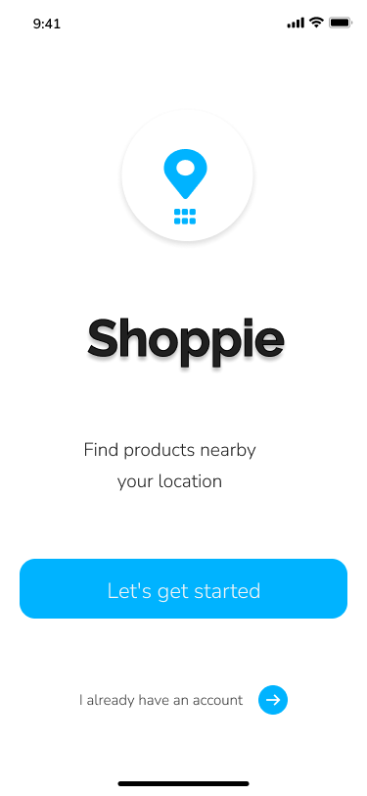
Chapter 5 | Simulation of Mobile App

5.1 Splash Screen : The splash screen serves as the introductory screen of the mobile apps, providing a visually appealing start and preparing the user for the app’s main functionalities.

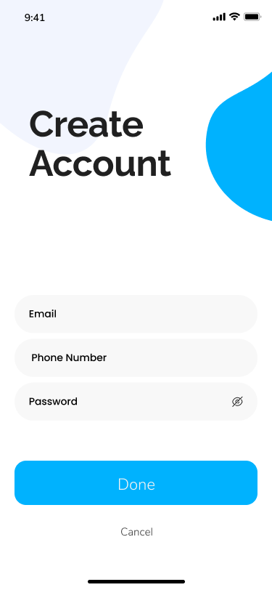

5.2 Create Account : The “create account” feature allows users to sign up by entering their details like Email, Phone no, Password, which is then validated and sent to Firebase Authentication to create a new user account. Upon successful account creation, users are redirected to the home screen.



5.3 User Login : Users enter their credentials (email and password) on the login screen, which are then verified by the Firebase Authentication API; upon successful verification, users are redirected to the home screen, while invalid credentials trigger an error message prompting users to no user found for this credentials.

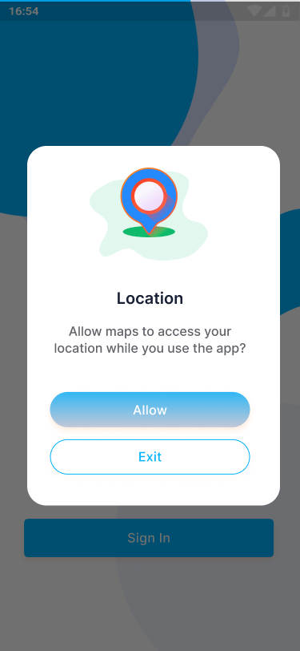
5.4 Location Detection: The app uses the Google Maps API to detect the user’s current location, which is then used to show available nearby products.

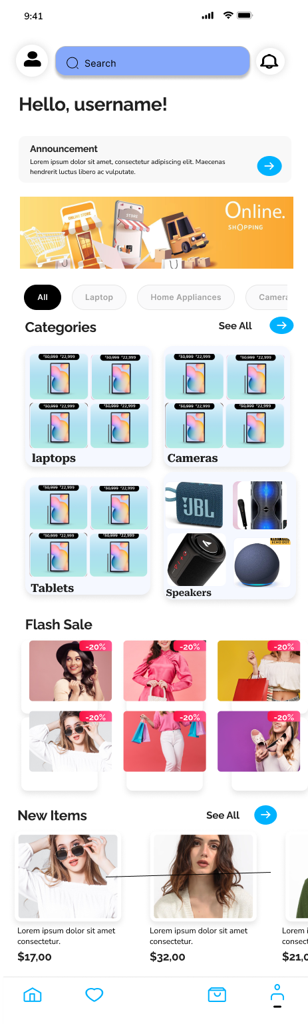

5.4 Home Screen : The home screen serves as the central hub where users can initiate product searches and access other functionalities.

Provide options for product search, viewing recommendations, and accessing user settings, typically through buttons or a navigation drawer.

5.5 Fetch Data from Firebase Realtime Database: The application fetches real-time product data and availability from the Firebase Realtime Database.
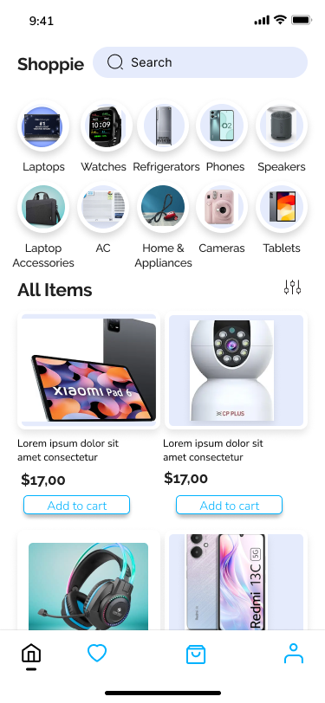

5.5.1 Data Retrieval: Query the Firebase Realtime Database to retrieve product details such as name, image, description, price, and availability.

5.5.2 Real-Time Updates:Ensure any changes in the database are immediately reflected in the app by using Firebase’s real-time synchronisation capabilities.

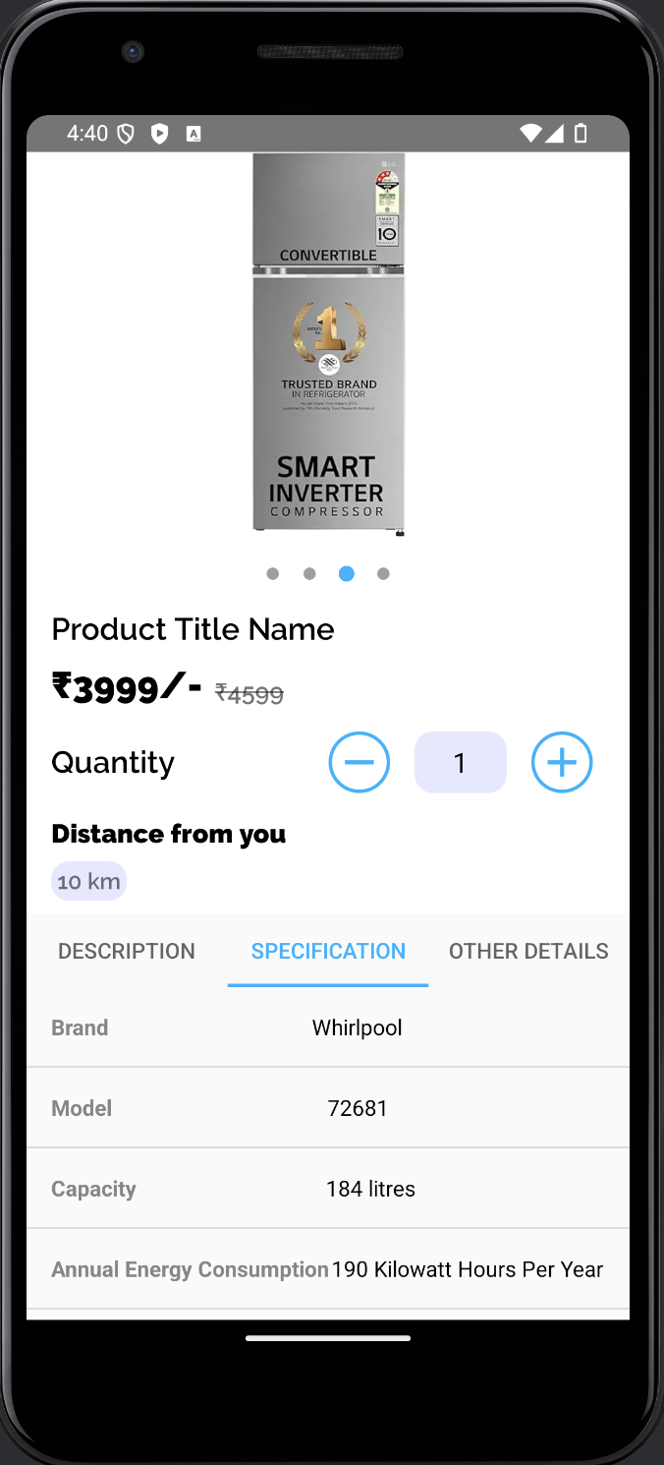
5.6 Display Product Information:Product details, including images, descriptions, prices, and ratings, are displayed on the UI.

5.6.1 Product List: Display a list of products matching the search criteria in a RecyclerView or similar component.

5.6.2 Product Details: On selecting a product, navigate to a detailed view displaying comprehensive product information fetched from Firebase.

Chapter 6 | Discussion

6.1 Learning Process and Growth

Embarking on the development of a location-based product search mobile application has been a transformative journey that has significantly contributed to both my personal and professional growth. This chapter discusses the key learnings and growth I experienced throughout the project.

6.2 Technical Skill Development

One of the most significant areas of growth has been in my technical skills. Developing this application required a deep understanding of several technologies and tools:

6.2.1 Programming Languages:
• My proficiency in Java has improved significantly. Working on various aspects of the application, from user authentication to location services integration, allowed me to apply these languages in a real-world context.

6.2.2 Development Tools:
• Using Android Studio as the primary development environment enabled me to become more proficient with this IDE. I learned how to effectively navigate its features, debug code, and optimise app performance.

6.2.3 APIs and Libraries:
• Integrating Google Maps API and Firebase services (Authentication, Realtime Database) was a new challenge. I gained valuable experience in how to integrate and utilise these powerful tools to enhance the app’s functionality.

6.2.4 Database Management:
• Understanding the differences between SQLite and Firebase for local and cloud-based storage respectively, allowed me to choose the best solution for different scenarios within the app. I also honed my skills in designing efficient database schemas and performing CRUD operations.

6.3 Problem-Solving and Debugging

Throughout the project, I encountered numerous challenges that required innovative problem-solving:

6.3.1 Location Services Accuracy:
• Ensuring the accuracy of location data was crucial for the app’s success. I learned to handle various scenarios where GPS or network-based services might provide inaccurate data, implementing fallback mechanisms to maintain reliability.

6.3.2 User Interface Design:
• Designing a user-friendly and visually appealing interface was critical. I experimented with different design principles and tools, improving my ability to create intuitive and engaging user experiences.

6.3.3 Performance Optimization:
• Balancing app performance with battery consumption posed a significant challenge. I explored various optimization techniques, such as efficient data fetching and background processing, to ensure the app ran smoothly without draining the device’s battery.

6.4 Collaboration and Communication

Working on this project also enhanced my collaboration and communication skills:

6.4.1 Version Control:
• Utilising Git for version control taught me the importance of maintaining a clean and organised codebase. It also facilitated better collaboration, allowing for seamless integration of different components developed concurrently.

6.4.2 Documentation:
• I learned the value of thorough documentation, both for personal reference and for enabling team members to understand the project’s structure and functionality. Clear and concise documentation proved essential for efficient collaboration.

6.4.3 Feedback and Iteration:
• Regularly seeking feedback from peers and mentors helped me refine the application. This iterative process of testing, receiving feedback, and making improvements was crucial for developing a robust and user-friendly product.

6.5 Personal Growth

Beyond technical skills, this project contributed to my personal development in several ways:

6.5.1 Time Management:
• Balancing the demands of a complex project with other responsibilities taught me effective time management. Prioritising tasks and setting realistic deadlines became essential skills.

6.5.2 Resilience and Adaptability:
• Facing and overcoming obstacles throughout the project reinforced my resilience. I learned to adapt to new challenges and remain focused on finding solutions, even when initial attempts failed.

6.5.3 Continuous Learning:
• The rapidly evolving field of mobile app development necessitates continuous learning. This project reinforced the importance of staying updated with the latest technologies and best practices, fostering a mindset of lifelong learning.

Chapter 7 | Testing and Debugging

7.1 Introduction

Testing and debugging are critical phases in the software development lifecycle, ensuring that the application functions correctly and provides a smooth user experience. This chapter outlines the approaches and methodologies used to test and debug the location-based product search mobile application.

7.2 Testing Strategy

A comprehensive testing strategy was implemented to ensure all components of the application function as expected. The strategy included unit testing, integration testing, user acceptance testing, and automated testing.

7.2.1 Unit Testing:
• Objective: To test individual components and methods in isolation.
• Tools Used: JUnit for Java and Kotlin.
• Approach:
• Write test cases for each function and method.
• Test the business logic, data validation, and error handling independently.
• Ensure each unit of code performs correctly without dependency on external systems.

7.2.2 Integration Testing:
• Objective: To test the interaction between different modules and components.
• Tools Used: Android Testing Framework, Espresso.
• Approach:
• Test the integration of user authentication with Firebase.
• Verify the interaction between the search functionality and location services.
• Ensure smooth data flow between the frontend and backend components.

7.2.3 User Acceptance Testing (UAT):
• Objective: To validate the application against user requirements and ensure it meets the end-user’s needs.
• Approach:
• Involve potential users in testing the app’s functionalities.
• Gather feedback on usability, performance, and overall user experience.
• Make necessary adjustments based on user feedback to enhance the app’s functionality and user experience.

7.2.4 Automated Testing:
• Objective: To perform repetitive tests efficiently and ensure consistent performance.
• Tools Used: Espresso for UI testing, Robolectric for Android testing.
• Approach:
• Automate test cases for critical functionalities such as user login, product search, and location-based results.
• Implement continuous integration (CI) to run automated tests on every code commit.
• Ensure that new code changes do not introduce regressions.

7.3 Debugging Process

Debugging was an integral part of the development process, involving the identification and resolution of defects or issues within the application.

7.3.1 Debugging Tools and Techniques:
• Android Studio Debugger:
• Use breakpoints to pause code execution and inspect variables.
• Step through code to understand the flow and identify issues.
• Logcat:
• Utilise Logcat for real-time logging of app behaviour.
• Filter logs to trace errors and monitor application performance.
• Crashlytics:
• Implement Firebase Crashlytics to capture and report crashes.
• Analyse crash reports to identify and fix issues causing the application to crash.

7.3.2 Common Issues and Resolutions:
• Location Accuracy:
• Issue: Inaccurate location data affecting search results.
• Resolution: Implement fallback mechanisms and error handling to manage inaccuracies.
• Network Connectivity:
• Issue: Application behaviour in poor network conditions.
• Resolution: Add network checks and provide user feedback when connectivity is insufficient.
• UI/UX Inconsistencies:
• Issue: Inconsistent user interface elements and navigation.
• Resolution: Conduct thorough UI testing and follow design guidelines to ensure a cohesive user experience.

7.3.3 Performance Optimization:
• Battery Consumption:
• Issue: High battery usage due to continuous location tracking.
• Resolution: Optimise location requests and use efficient background processing.
• App Responsiveness:
• Issue: Slow response times when fetching data from the server.
• Resolution: Implement efficient data fetching techniques and optimise server-side performance.

7.4 Testing and Debugging Outcomes

The rigorous testing and debugging process led to several positive outcomes:
• Improved Stability: Identified and resolved critical bugs, resulting in a more stable application.
• Enhanced Performance: Optimised the app’s performance, ensuring smooth and responsive user interactions.
• Better User Experience: Incorporated user feedback to refine the app’s interface and functionality, leading to a more intuitive and enjoyable user experience.

Chapter 8 | Conclusion

8.1 Summary of Experience
The internship involved developing a location-based product search mobile application, integrating Java, Android SDK, Firebase, and Google Maps API. It provided hands-on experience in implementing core features like user authentication, geolocation services, and real-time data management.

8.2 Contributions
Significant contributions included:
- Designing an intuitive user interface for enhanced usability.
- Implementing functionalities crucial for seamless product searches and personalised recommendations.
- Conducting thorough testing to ensure high performance and reliability.

8.3 Future Aspects

While the current version of the application achieves its core goals, there are several areas for future enhancement and expansion. These future aspects aim to improve the application’s functionality, user engagement, and scalability.

8.3.1 Advanced Search Filters:
• Implement more sophisticated search filters, such as price range, brand, and product ratings, to help users find products more precisely.
• Introduce sorting options, such as sorting by distance, popularity, or newest arrivals.

8.3.2 Augmented Reality (AR) Integration:
• Explore the integration of AR to allow users to visualise products in their environment before making a purchase.
• Implement AR-based navigation to guide users to nearby stores or product locations.

8.3.3 Multilingual Support:
• Expand the application’s reach by adding support for multiple languages, catering to a broader audience.
• Implement language preference settings in the user profile.

Chapter 9 | References

1. Android Developer Documentation:
• “User Authentication with Firebase” - Firebase Authentication
• “Location Services in Android” - Android Location Services
• “Google Maps Platform Documentation” - Google Maps API

2. Online Tutorials and Courses:
• “Android App Development for Beginners” - Udemy Course by Dannies

3. Articles and Blogs:
• Android Developers Blog: Best Practices for App Development - Android Developers Blog

4. Version Control and Collaboration:
• “Pro Git” by Scott Chacon and Ben Straub - Pro Git Book
• GitHub Guides: Mastering Issues - GitHub Guides

5. User Experience and Design:
• Material Design Guidelines - Material Design

